Exterior Point
# Source: AI Source: Provided by: [Data Path: Persons Table -> ID Column: 1, Name_En Column: Motasem Essam] -> From: [ChatGPT] on [7/25/2026]
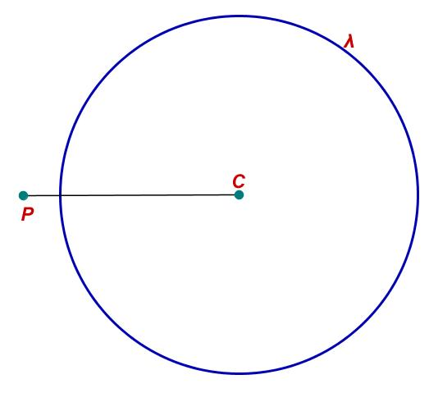
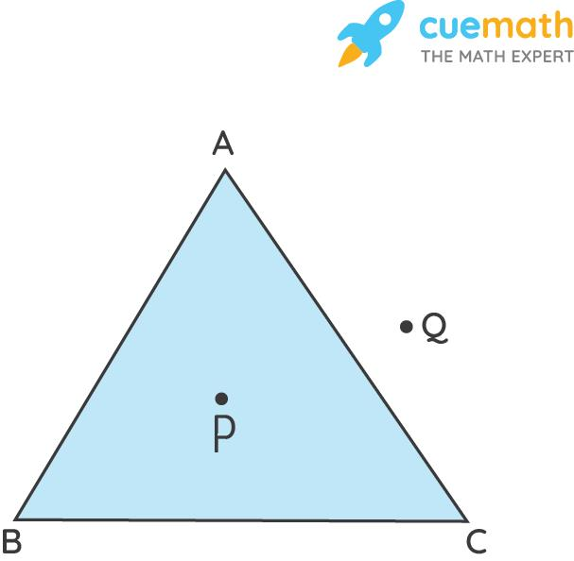
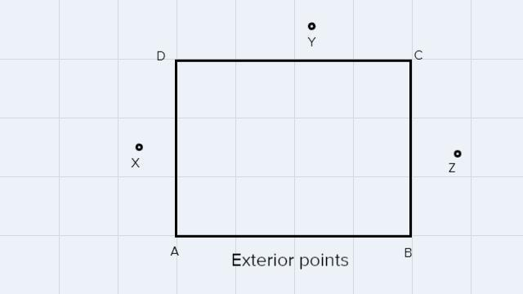
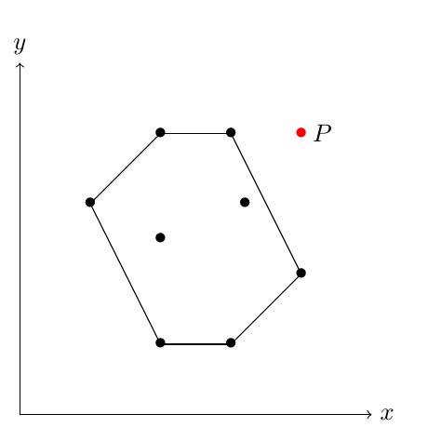

Definition
# Source: AI Source: Provided by: [Data Path: Persons Table -> ID Column: 1, Name_En Column: Motasem Essam] -> From: [ChatGPT] on [7/25/2026]
An Exterior Point is a point that lies completely outside a geometric figure or region. It does not belong to the figure and is not on its boundary (edge).
An exterior point is located in the surrounding space outside the geometric object.

Characteristics
# Source: AI Source: Provided by: [Data Path: Persons Table -> ID Column: 1, Name_En Column: Motasem Essam] -> From: [ChatGPT] on [7/25/2026]
An exterior point:
- Lies outside a geometric figure.
- Is not on the boundary.
- Is not inside the figure.
- Does not belong to the figure or its interior.
- Can exist relative to both two-dimensional and three-dimensional objects.

Illustration
# Source: AI Source: Provided by: [Data Path: Persons Table -> ID Column: 1, Name_En Column: Motasem Essam] -> From: [ChatGPT] on [7/25/2026]
Exterior Point Relative to a Triangle
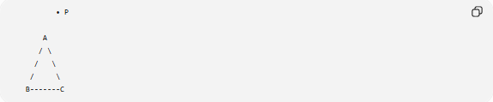
• P

A
/ \
/ \
/ \
B-------C
Point P is an exterior point because it lies outside triangle ABC.

Exterior Point Relative to a Circle
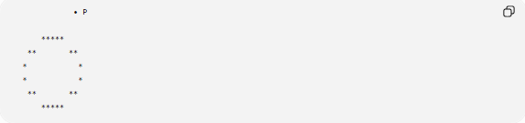
• P

*****
** **
* *
* *
** **
*****
Point P is outside the circle and is therefore an exterior point.

Mathematical Description
# Source: AI Source: Provided by: [Data Path: Persons Table -> ID Column: 1, Name_En Column: Motasem Essam] -> From: [ChatGPT] on [7/25/2026]
For a geometric figure $F$:
A point $P$is an exterior point if:
- $P$is not inside the figure.
- $P$is not on the boundary.
Symbolically:
$$P∉F$$

Examples
# Source: AI Source: Provided by: [Data Path: Persons Table -> ID Column: 1, Name_En Column: Motasem Essam] -> From: [ChatGPT] on [7/25/2026]
Exterior points may lie outside:
- Triangle
- Rectangle
- Square
- Circle
- Polygon
- Ellipse
- Solid objects

Properties
# Source: AI Source: Provided by: [Data Path: Persons Table -> ID Column: 1, Name_En Column: Motasem Essam] -> From: [ChatGPT] on [7/25/2026]
An exterior point:
- Does not belong to the figure.
- Is separated from the figure by empty space.
- May be connected to the figure by line segments.
- May become an interior point if the figure expands.

Applications
# Source: AI Source: Provided by: [Data Path: Persons Table -> ID Column: 1, Name_En Column: Motasem Essam] -> From: [ChatGPT] on [7/25/2026]
Exterior points are used in:
- Geometry
- Computational Geometry
- Computer Graphics
- CAD (Computer-Aided Design)
- GIS (Geographic Information Systems)
- Robotics
- Collision Detection
- Navigation
- Spatial Modeling

Advantages
# Source: AI Source: Provided by: [Data Path: Persons Table -> ID Column: 1, Name_En Column: Motasem Essam] -> From: [ChatGPT] on [7/25/2026]
Using exterior points helps to:
- Distinguish outside regions from interior regions.
- Perform point-location tests.
- Support geometric algorithms.
- Define boundaries accurately.
- Analyze spatial relationships.

Limitations
# Source: AI Source: Provided by: [Data Path: Persons Table -> ID Column: 1, Name_En Column: Motasem Essam] -> From: [ChatGPT] on [7/25/2026]
Exterior points:
- Depend on the definition of the figure's boundary.
- May require computational methods to determine for irregular shapes.

Comparison with Other Types of Points
# Source: AI Source: Provided by: [Data Path: Persons Table -> ID Column: 1, Name_En Column: Motasem Essam] -> From: [ChatGPT] on [7/25/2026]
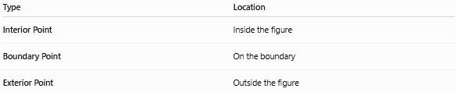
Type | Location
Interior Point | Inside the figure
Boundary Point | On the boundary
Exterior Point | Outside the figure

Key Points
# Source: AI Source: Provided by: [Data Path: Persons Table -> ID Column: 1, Name_En Column: Motasem Essam] -> From: [ChatGPT] on [7/25/2026]
- An Exterior Point lies outside a geometric figure.
- It is not on the boundary.
- It does not belong to the figure.
- Exterior points are widely used in geometry, computational geometry, CAD, GIS, robotics, and computer graphics.

Conclusion
# Source: AI Source: Provided by: [Data Path: Persons Table -> ID Column: 1, Name_En Column: Motasem Essam] -> From: [ChatGPT] on [7/25/2026]
An Exterior Point is a point located entirely outside a geometric figure, neither belonging to its interior nor lying on its boundary. Exterior points are essential for distinguishing the space surrounding geometric objects and are widely used in geometry, computational geometry, engineering, computer graphics, CAD, GIS, navigation, and spatial analysis, where determining whether a point lies inside, on, or outside a figure is fundamental to many mathematical and practical applications.

